LASER CONTROL CABLE

- PARTS:

QUANTITY: PART #: NOMENCLATURE: LENGTH:

1 PER CABLE 19224-2 CABLE, FLT RBN, 10-CON, 22AWG 26 INCHES

2 PER MACHINE 17420-8 HOUSING, CLOSED END FEMALE N/A

2 PER MACHINE 17418-8 COVER, STANDARD N/A

- ASSEMBLY:

- REMOVE THE WHITE AND BLACK WIRES FROM THE CABLE.

- SEPARATE THE WIRES AT THE ENDS OF THE CABLE SO THAT THEY CAN BE CRIMPED INTO THE CONNECTOR.

- CRIMP THE WIRES INTO THE CONNECTOR, ACCORDING TO DIAGRAM 1.

- INSERT THE COVER OVER THE CONNECTOR.

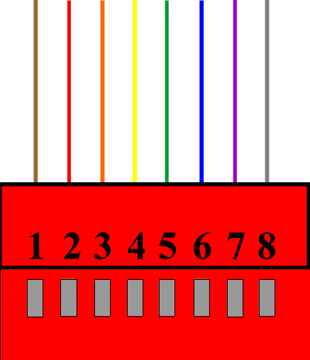

DIAGRAM 1

